Association for Professionals in Infection Control and Epidemiology, Inc.
San Diego and Imperial Counties Chapter 057
Minutes for April 12, 2023
TOPIC | PRESENTER | DISCUSSION | ACTION/ASSIGNMENT
1. Call to Order | Jarrod Becasen | TIME: 1300 | None
2. Recognition/ Introductions | Jarrod Becasen | Meeting sponsored by Germitec.  New Members or Visitors:  When new members sign up, APIC alerts the chapter.  Paul Georgie – Magnolia Medical-Steripath  Gina Vander Thee – Aramark  Denise Graham – Synexis  Patricia Minero  Alisha Allen – CorMedix  Brian Church – BD  Shweta Warner  New CIC Certifications or Re-certifications:  Julie with Sharp Chula Vista  Arie Intern UCSD  “Effective January 1, 2026, the open-book untimed recertification examination will no longer be offered. Recertification will be obtainable through infection prevention units (IPUs) or by retaking the initial CIC® proctored examination.” https://www.cbic.org/CBIC/Recertification.htm | None
3. Old Business | Jarrod Becasen | Minutes approved for March 2023. https://sdapic.org/wp-content/uploads/2023/04/SDIC_minutes-03.2023.docx  Frank motioned to approved. Kristen seconded. | Minutes Approved.
4. New Business | Jarrod Becasen | In-Person Engagement Incentive. This incentive is to encourage in person attendance at our monthly meetings. A little raffle will be done at the end of the meeting, gifts could be items such as gift cards.  Looking at bringing back the Lunch & Networking Hour, pending Sharp changes to tier level  State APIC member responses to April 3rd changes survey  https://docs.google.com/forms/d/e/1FAIpQLSdAQMYmMtKR-LlkwGXqfklm-hnzis6BHNd50YW4iMQfjCvIfg/viewanalytics  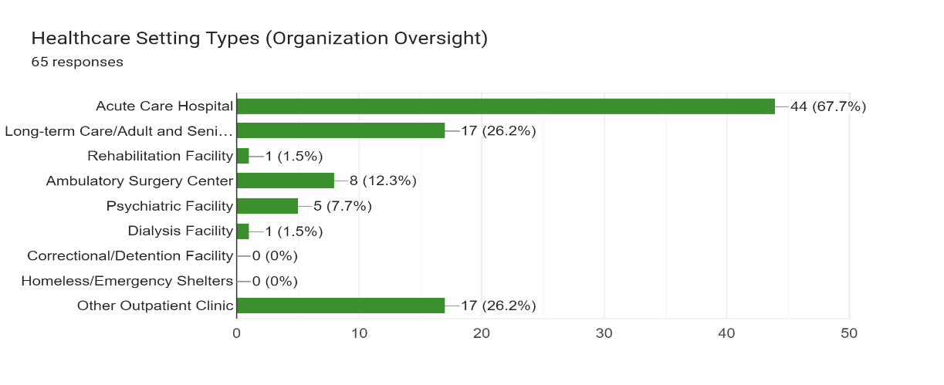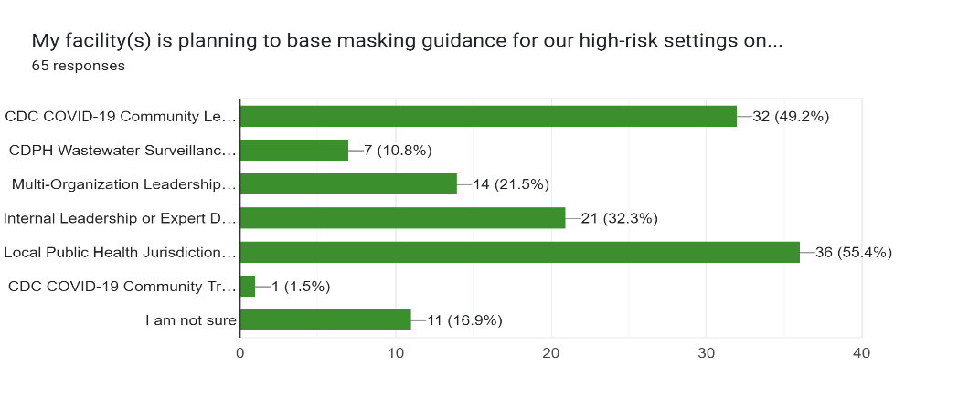  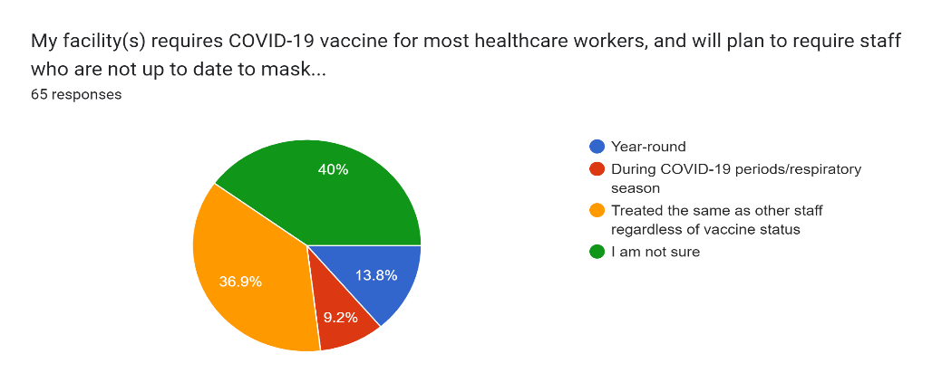  SDPH: Changes Related to the End of State and Local Emergencies (Updated 4/21/2023)  https://www.sandiegocounty.gov/content/sdc/hhsa/programs/phs/community_epidemiology/dc/2019-nCoV/health-order.html | Encourage members to attend monthly meetings in person.  Stay Tuned.
5. Membership Report | Liz Jefferson | Numbers current as of April 9, 2023:  153 Members  115 Full/Active Members  46 CIC  41 Associate Members (vendors)  Membership is receiving new member reports and sending out welcome letters. | None.
6. Treasurer’s Report | Viviana Parra | March 2023 Treasurer’s Report.  - Beginning Checking 02/01/2023 $11,332.51  Cash Flow  Deposits: $0  Disbursements: $449.23 (travel expenses, google drive)  Ending balance: 02/28/2023 $10,883.28  - Mutual Fund Investment: March 1 – March 31, 2023  Balance as of March 1, 2023 $22,748.61  Income: $ 0.01  Fees: $ 0.00  Change in Investment Value: $ (320.97)  Balance as of March 31, 2023: $23,069.59  Vivian will work on taxes in the next week, although the due date has been extended to October 2023. | None  Taxes pending completion.
7. Education Report | Jessica Alicdan | Presentation Topics for 2023 monthly meetings have been determined:  April: Sterilization  May: CDPH CRO (CRAB/CRPA) – What IPs need to know and resources  June: APIC National  July: Summer Event  CACC + SDIC APIC Joint CEU Event: PIV-BSI vs. CLABSI  Aug: CACC in Southern California (Coastline hosting)  Sep: Joint APIC Chapter Annual Conference, planning has begun  October: Round Table Discussion – IPs choice of topics (survey open May – Sep)  November: SDIC APIC LTC Conference  December: SDIC APIC Holiday Party | Jessica to send out Roundtable meeting invite.
8. Legislative Report | Kim Delahanty | APIC Legislative Chapter Presentation: Infection Preventionists and APIC Priorities  Monthly National APIC meeting:  Report from APIC at the Federal and US level.  CLR Report Links: (available on SD APIC website)  CLR March 2023  CLR April 2023  CLR April 2023.2  Appropriations request: Agency for Healthcare Research and Quality for $500M in FY 2024.  Appropriations request: This letter requests Congress fund the Advanced Molecular Detection program at $175M in FY 2024.  Appropriations request: Addressed to the House and Senate Committees on Labor-Health and Human Services and calls for a 302(b) allocation that addresses gaps created due to underfunding.  Appropriations request: $340 million for the Data Modernization Initiative (DMI) at the Centers for Disease Control and Prevention (CDC) and $100M for CDC’s newly established Center for Forecasting and Outbreak Analytics (CFA).  Appropriations request: Urges appropriators to fully fund the Public Health Workforce Loan Repayment Program at its $100 million authorization level and provide $50 million to launch the new Bio-Preparedness Workforce Pilot Program.  Appropriations request: This letter highlighted key programs combating antimicrobial resistance and the necessary funding needed in FY 2024.  APIC National Survey  - APIC is collecting member information to inform U.S. regulators regarding the challenges associated with medical device IFUs.  - Survey should take less than 10 minutes  - 1 survey per facility  - Responses requested by April 11  Judene Bartley Advocacy in Action Scholarship ***Specific to Public Policy  To apply send the following:  - Curriculum Vitae (CV)  - Essay – 700 words or less detailing prior involvement in public policy initiatives  - Letter of reference from an APIC or SHEA member outlining their support for your application  APIC State Legislative Update  California Legislation is still in Session, allowing attendance for LEG Day.  Vaccine Legislation  - Chapters have expressed concerns regarding vaccine legislation in their states  - APIC has a pre-written action alert supporting pro-vaccine legislation  - If your chapter is interested in further action, please contact us at legislation@apic.org  Federal Issues – Congressional Activity  - Appropriations Season  - HELP Committee looking at workforce legislation  - Reauthorization of the Pandemic and All Hazards Preparedness Act (PAHPA)  - Debt Ceiling  - Tik Tok Ban  Question: Has there been any discussion for DEI for Infection Prevention and Control? Answer: Kim is part of DEI and will bring the question up. | None.  Access CLRs on APIC website under meeting tab.  It is expected that APIC will send a letter with the shared data collected.  Apply for Scholarship
9. Social Committee | Latrice Jackson-Washington,  Christian Andaya,  Heidi Campas-Higgins | Summer Social. Save the Date: Wednesday, July 12, 2023, 11 AM to 3 PM, location: Punch Bowl Social, San Diego, CA. APIC | San Diego Chapter » 2023 Summer Event (sdapic.org)  - VIP upstairs Bowling Lanes  - Ping Pong Lounge  - Food, Beverages  - Capacity is 60 people  Vote to change the date from Wednesday, July 12, 11am -3pm to Friday, July 14, 3-4 pm.  Will need to adjust joint CACC event since this is the same day.  Question: Can we bring a plus 1? Answer: no objections noted. | Vote Approved. Will need to verify with venue if this date is available.
10. Nomination Committee | Lisa Mattia and Claudia Sanchez Goad | Applications open for APIC Education Support Awards 2023. APIC | San Diego Chapter » Important Links & Tools (sdapic.org)  - There is one $2000 for National APIC Conference (Application Due Date: May 26, 2023) https://www.emedevents.com/c/medical-conferences-2023/association-for-professionals-in-infection-control-and-epidemiology-apic-2023  - (6) $500 for Standard Award (Application Due Date: December 31, 2023) https://forms.gle/pJzRgucefbC1SLgv7  - There have been #3 applicants who submitted for this award. Board met and approved giving the awards to the #3 applications. Congratulations to Emily Barnard, Shannon Oriola, and Julie McShane.  - Still available are #3 that are earmarked for SNF/LTC IP chapter participant  - Link to complete application: https://forms.gle/pJzRgucefbC1SLgv7  If you receive an award, it is encouraged that you would come back and share with the committee what you learned from the conference.  There were no applications for LEG Day. | Apply, if interested.  None.  SNF/LTC members to submit application, if interested.  None.
12. Updates
12.1 HAI Advisory Committee | Deweese Quigley | No official report. There is an Acute Care Hospital IP training online. Go to program website to check it out. https://www.cdph.ca.gov/Programs/CHCQ/HAI/Pages/HAIProgramHome.aspx | None
12.2 CACC Meeting | Jarrod Becasen & Jessica Alicdan | Meeting schedule posted https://community.apic.org/cacc/events/meetings  May 5th Leg Day – RSVP here: https://forms.gle/MtQzFxZ7N1sVvLgt6  If you RSVP, CACC to start pairing people up.  Leg Day Meeting, May 5th  Hosted by Sierra Chapter “Leg Day” Host Chapter Contact: Abdul Hameed  In-person Location: Shriner’s Hospital for Children  Zoom Meeting Link  Add to your Calendar  RSVP here  Joint Chapter Education Schedule  SFBA APIC Chapter April 12, 2023  San Diego plans to host July session | None.  RSVP, if interested in attending LEG Day.
12.5 IDAC Report | Lisa Kilgore | No Report.
12.6 GERM Report | Frank Edward Myers III | No Report.
13. Long-Term Care | Israel Sanchez | No Report. | None
14. Ambulatory Care | Janessa Esteban | No Report. | None.
15. Pediatric Care | Rady Children’s | - Still seeing high respiratory viruses, mostly adenovirus  - Closed drive up COVID testing | None
16. County Epidemiology | Grace Kang | Resuming meetings at the County Operations Center.  12th Annual Vector-Borne and Zoonotic Disease Meeting  June 7, 2023, 8:30 AM-12:30 PM  5520 Overland Avenue, San Diego, CA 92123 ‐ Chambers Room  RSVP to the Epidemiology and Immunization Services Branch at Lourdes Garber, lourdes.garber@sdcounty.ca.gov For questions, contact Sierra Bregman at sierra.bregman@sdcounty.ca.gov  Changes over last few weeks.  - CDPH removed healthcare facility mask mandate, County no longer has this requirement, their position is to strongly recommend masking in patient care settings.  - Influenza season, vaccination or mask mandate, confirmed that it ended on March 31, 2023. If you see other dates past March 31st, please let Grace know so the County can correct.  - Number of CAHANs have been released over the last month.  Mpox in particular, has decreased but still circulating, County still offering testing and appointments through STD clinics.  - Increase Norovirus. There were 7 outbreaks last week, please continue to report.  - Recall of imported frozen organic strawberries – following Hep A outbreak. Separate Hep A strain that the one reported in homeless population.  - Candida auris in media recently. County to release a new CAHAN to provide information. | RSVP, if interested in attending.
17. Other Announcements, Questions, Comments | Group | Recent Surveys  - Palomar just finished TJC for both campuses.  - Focused on satellite home health  - Wound care clinics  - IFUs for rehab equipment  - IFUs for Vaginal probes  Rady’s Home Care Agency, Licensing and CDPH survey  - Hand hygiene  - GACH is still looking at COVID vaccine/Staff  Open Positions:  Scripps Green 0.8 FTE (4 8/hr days)  APIC Website: New Positions in San Diego or Imperial County  https://sdapic.org/important-links-tools/  Questions:  - Any update on Panda Warmers? Frank shared that the FDA is aware of the issue.  Training:  Infection Prevention Biofilm and Surgical Instrumentation by Tamara Behm. https://sdapic.org/wp-content/uploads/2023/04/Biofilm-and-Instrumentation-Tamara-Behm.pdf  NEXT MEETING: Wednesday, May 10, 2023  Location: Sharp Copley, 5651 Copley Dr, San Diego, CA 92111, Room C  Sharp Copley is within the “substantial tier” and currently does not allow food inside  Virtual Link: APIC Meeting Zoom Link May.10.2023 | None  Reach out to APIC practice guidance, ask them to revisit.
18. Adjournment | Jarrod Becasen | TIME: 1500 | None

